**MATHS-X (SA-II)**

**[Time Allowed: 3.00 Hours] [Maximum Marks: 90]**

**General Instructions:**

**(i) All questions are compulsory.**

**(ii) The question paper consists of 31 questions divided into four sections A,B,C and D .Section A**

**comprises of 4 questions of 1 mark each. Section B comprises of 6 questions of 2 marks each,**

**section C comprises of 10 questions of 3 marks each and Section D comprises of 11 questions of**

**4 marks each.**

**(iii) There is no overall choice.**

**(iv) Use of calculators is not permitted.**

**(v) An additional 15 minutes time has been allotted to read this question paper only.**

**Section -‘A’**

**1**. If a, are roots of the equation



(a)0 (b)-1 (c)2 (d)-2

**2**.The tenth term of an A.P.-10,-1.5,-20,… IS

(a)3.5 (b)5.5 (c)-5.5 (d)-6.5

**3**.If the length of tangent from a point A at a distance of 26 cm from the centre of the circle is 10

cm,then the radius of the circle is

(a)22 cm (b) 24 cm (c)21 cm (d)23 cm

4.A card is drawn from a pack of cards numbered 1 to 52 .The probability that the number on the card is

a perfect square is

(a) (b)  (c)  (d) 

5.In the following figure ,the angles of depression from the observing position O1 A and O2 of the object

at A are

(a)300 and 450  (b)300 and 600 (c)450 and 300 (d)600 and 300

6.If the mid –point of the line segment joining the points P(6,k-2)and Q (-2,4) is (2,-3),then the value of k

is

7. A wire in the shape of a square of side 88 cm, is bent so as to from a circular ring .The radius of the

circle will be

(a)14 cm (b) 28 cm (c) 56 cm (d)42 cm

8.If the surface areas of two spheres is in the ratio 4:9 ,then the ratio of their radii is

(a)2:3 (b) 3:2 (c)1:3 (d)3:1

Section B

Question numbers 9 to 14 carry 2 marks each.

9. Find the roots of the following quadratic equation: 

10.If the numbers x- 2,4x-1 and 5x+2 are in A.P.,find the value of x.

11. Point P(5,-3) is one of the two points of trisection of the segment joining the points A(7,-2)and

B(1,-5) near to A. Find the coordinates of the other point of trisection.

12. In figure ,TP and TQ are tangents from T to the circle with centre O and R is any point on the circle .If

AB is a tangent to the circle at R, prove that 

13. PQRS is a square land of side 28 m .Two semicircular grass covered portions are to be made on two

its opposite sides as shown in the figure .How much area will be left uncovered?

14.A pendulum swings through an angle of 300 and describe an are 8.8 cm in length .Find the length of

the pendulum.

Section ‘C’

Question numbers 15 to 24 carry 3 marks each.

15. Find the sum of first n terms of an A.P. whose nth term is 5n-1.Hence find the sum of first 20 terms.

16. Find the roots of the following quadratic equation:

17. From a point on a bridge across a river, the angles of depression of the banks on opposite sides of

the river are 300 and 400 ,respectively .If the bridge is at a height of 3 m form the banks, find the

width of the river.

18. Find an A.P.whose fourth term is 9 and the sum of its sixth term and thirteenth term is 40.

19. Draw a pair of tangents to a circle of radius 3 cm, which are inclined to each other at an angle of 600.

20. Two concentric circles are of radii 7 cm and r cm respectively, where r >7.A chord of the larger circle

,of length 48 cm ,touches the smaller circle .Find the value of r.

21. In figure, APB and CQD are semi-circles of diameter 7 cm each, while ARC and BSD are semi-circles of

diameter 14 cm .Find the perimeter of the shaded region.

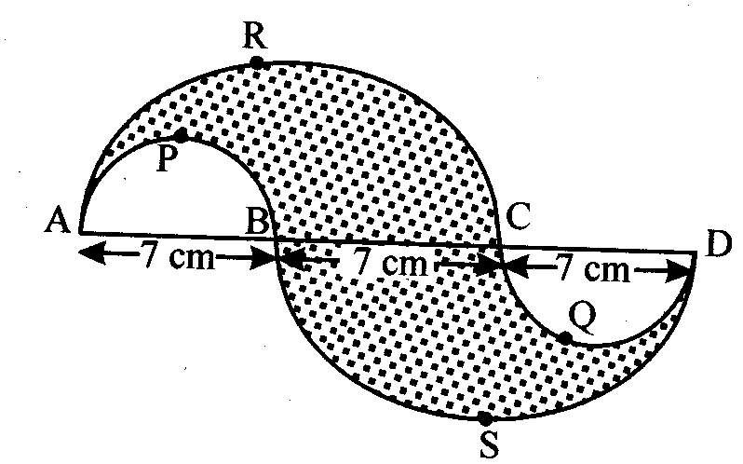

22. Two different dice are thrown at the same time .Find the probability that the sum of the two

numbers appearing on the top of the dice is 7.

23.The dimensions of a metallic are 100 cm X 80 cm X 64 cm.It is melted and recast into a cube .Find the

surface area of the cube.

24. A copper rod of diameter 1 cm and length 8 cm is drawn into a wire of length 18 m of uniform

thickness .Find the thickness of the wire.

Section; D’

Question numbers 25 to 34 carry 4 marks each.

25.Prove that the point A(4,3),B(6,4),(5,-6)and D(3,-7)in that order are the vertices of a parallelogram.

26. The points A(2,9),B(a,5),C(5,5) are the vertices of a triangle ABC right angled at B.Find the value of ‘a’

and hence the area of 

27. A train travels at a certain average speed for distance of 63 km and then travels distance of 72 km at

an average speed of 6 km/h more than its original speed .If it takes 3 hours to complete the total

journey, what is its original average speed?

28. The sum of n, 2n, 3n terms of an A.P.are respectively .Prove that: 

29. A strength highway leads to the foot of a tower .A man standing at the top of the tower observes a

car at an angle of depression of 300 ,which is approaching the foot of the tower with a uniform

speed .10 second later, the angle of depression of the car is found to be 600.Find the time taken by

the car to reach the foot of the tower from this point.

30. Hari,a cold milk-seller has set up his cold milk shop. He has two types of glasses in the shape of a

frustum of cone whose radii of the ends of frustum are 6 cm and 3 cm to serve the customers .The

height of the glass is 10 cm.

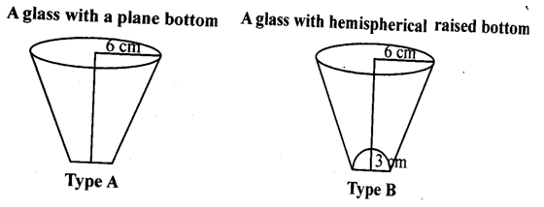

He decided to serve the customers in A type of glasses.

(i)Find the volume of glass of type A. (ii)Which glass has the less capacity?

(iii)By choosing a glass of type A, which value is depecited by cold milk-seller Hari?

31. Prove that the lengths of tangents drawn from an external point to a circle are equal.

32. From a solid cylinder of height 14 cm and base diameter 7 cm, two equal conical holes each of radius

2.1 cm and height 4 cm are cut of. Find the volume of the remaining solid.

33. In figure, a triangle ABC is drawn to circumscribe a circle of radius 2 cm such that the segments BD

and Dc into which BC is divided by the point of content D are of lengths 4 mc and 3 cm respectively .If

area of ,then find the lengths of sides AB and AC.

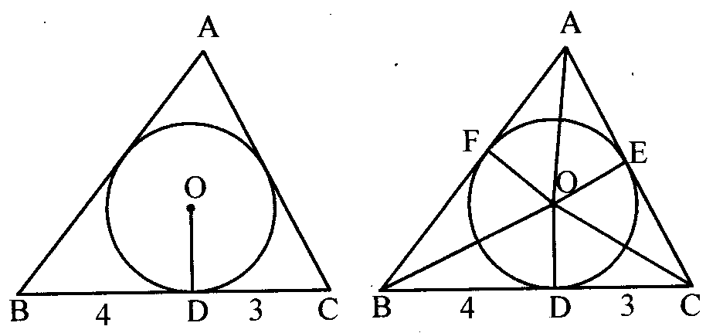

34. A circular target of radius 11 cm consists of an inner circle of radius 5 cm and three concentric circles

with same centre of radii 7 cm, 9 cm and 0cm dividing the target into four regions .If a shot hit the

target ,find probabilities of hitting each region .If you shoot the target 121 times, what is your

expectation? Can you improve your performance?